Intro to Programming (Python)

Assignment 07

# Overview

In this activity, you learn about exception handling and Python’s pickling module, and how you use them.

So far, I have provided links for you, but now it is your turn to do the research! I am hoping this is easy for you since you have visited many websites while performing the other modules.

One last twist! In addition to using Word document write-up, you create a GitHub webpage with the same content. Make the GitHub page look good, but don’t stress if the page does not look as nice as your Word document, it seldom does!

This assignment includes the following tasks:

1. Watch the module videos.
2. Read a chapter in your book.
3. Research exception handling in Python.
4. Research Pickling in Python.
5. Apply your knowledge.
6. Document your knowledge.
7. Post your files to GitHub
8. Create a GitHub webpage
9. Post your GitHub link
10. Submit your work.
11. Peer Review (Not Graded)

**Tip:** Consider the following questions while you work through the module to help you focus:

* What are the benefits of putting built-in Python command into functions?
* What are the benefits of using structured error handling?
* What are the differences between a text file and a binary file?
* How is the Exception class used?
* How do you "derive" a new class from the Exception class?
* When might you create a class derived from the Exception class?
* What is the Markdown language?
* How do you use Markdown on a GitHub webpage?

# Assignment Steps

The following assignment steps ask you to read about, perform, and write about programming.

***Note:*** *Course assignments help you learn through* ***reading****,* ***watching*** *demonstrations,* ***performing*** *programming in Python, and reflecting on what you learned through* ***writing****. You are strongly encouraged to continue your learning by experimentation.*

## Step 1 - Watch my Video Lecture

Please watch my course lecture for this module. You can find this module lecture(s) here: [ITFdn 110 - Python Course Videos](https://youtube.com/playlist?list=PLfycUyp06LG9fZllIqBrxLcNV4CR50HEX)

## Step 2 - Read a book chapter

Please **read chapter seven** in your textbook. You **do not have to perform the exercises or type in the code**, but it is best if you open the script files as you read about them. You can find the downloadable **book files** **on Canvas** for your convenience.

## Step 3 - Research Exception Handling in Python

**Search** the web for examples of how to use Python’s exception handing features. Make **note** of the **URL** for any pages you feel are good at explaining the subject, and **why** you feel that way.

## Step 4 - Research Pickling in Python

**Search** the web for examples of how to use Python’s Pickling features. Make **note** of the **URL** for any pages you feel are good at explaining the subject, and **why** you feel that way.

## Step 5 - Apply your knowledge

Now that you have reviewed the websites and videos, **create** a new script that demonstrates how **Pickling and Structured error** **handling** work.

a. **Create** a new sub-folder called Assignment07 inside the _PythonClass folder.

b. **Create** a new project in PyCharm that uses the _PythonClass\Assignment07 folder as its location

c. **Create** a file called, "Assigment07.py," in your project.

d. **Add** code to your script that performs the assignment’s task. Don't forget to include the script's header.

e. **Run** the script in BOTH PyCharm and an OS command/shell window and capture images of it working on your computer.

f. **Verify** that it worked, by locating the binary file and opening it in a text editor. The file should be in the same folder as your script when you used the correct, **relative** file path!

## Step 6 - Document your knowledge

After you have created and tested your Python script, **create** a document describing the steps you took in performing this assignment. **Use** screenshots and code samples to explain the process, just as was done in your book, my programming notes, and the web pages you reviewed. **Make sure** the document is in a Microsoft Word document (.doc or .docx) or .pdf file.

**Note**: Make sure you put it in a proper, professional level, formatting! It does not have to be perfect, but if you turn in a simple blob of text, you will not get credit for it! Here is a link that may help you understand what I am looking for: https://youtu.be/9ojhSW9ljjo (External Site)

## Step 7 - Post your Files to GitHub

In this module, you need to **post** your files on a public **GitHub repository** so that others may review it. Please post **both your Word document and your Python file**.

a. **Login** to <https://github.com> (*Make a new account if needed!*)

b. **Create** a repository called **"*IntroToProg-Python-Mod07" under your account.***

c. **Upload** both of your files to the repository.

d. **Commit** the changes to save your work.

**Important: You are creating a new GitHub repository in assignment 7. Using a different repository gives you practice managing multiple repositories and is part of the assignment.**

## Step 8 - Add a GitHub Webpage

You need to **add a GitHub webpage to your repository**. In this assignment, you must **take the text, images, and links from your Word document and put them into the GitHub webpage**.

There is much information on the Internet about the Markdown language, but you **should find all you need for this course on this one webpage**:

<https://help.github.com/en/github/writing-on-github/basic-writing-and-formatting-syntax>

***Important****: Learning to use Markdown and Jekyll could well be the topic of a complete course, but in this course,* ***you do NOT need to know much about Markdown*** *programming.* ***Please use only the basics shown in this module*** *instead of more advanced features* ***and do not worry about getting the format perfect!***

## Step 9 - Post a Link to GitHub

You need to share your work using the Canvas discussion board. To do so, you must **create** **post with a link to your GitHub site**. Other students use this link to perform a peer review.

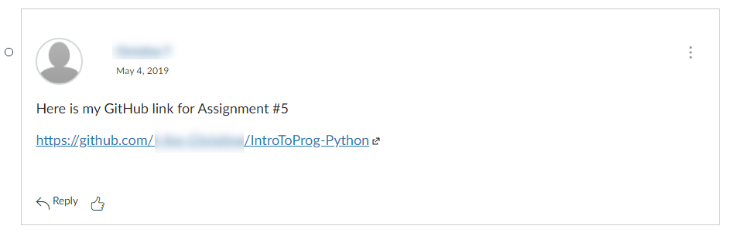

Figure 1. Posting a link to your GitHub repository

***Important:***

1. *Post only on the special discussion board called "Assignment 07 Documents for Review!"*
2. *Please copy and paste the URL for your new GitHub site into your MS Word knowledge document (Figure 2). This make grading a lot easier and is a big help! Thanks!!*

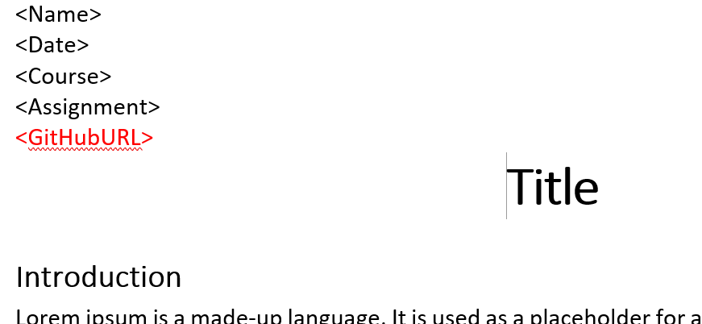

Figure 2. Adding your GitHub URL to your Word document

## Step 10 - Submit your work

Even though you have posted your file on GitHub, **you still need to submit your Python script and Word document as a Canvas assignment** for grading. So, place your document and python script in the Assignment07 folder. Zip this folder into a “.zip” file, then upload the .zip file to the class assignment page.

***Important:***

*1.* ***Upload*** *your work* ***to the Canvas*** *assignment’s as a* ***Zip file****.*

*2.* ***Post*** *a link to your GitHub site* ***on the******assignment textbox****.*

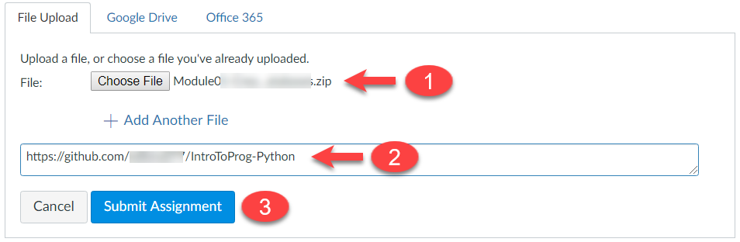

Figure 3. Posting your zip file to Canvas

## Step 11 - Perform a Peer Review (Not Graded!)

After you have posted your link to GitHub and submitted your assignment, go to the "Assignment 07 Documents for Review!" discussion board and **select another student's post and review.** Follow the link they posted and review their files on GitHub. **This is an informal review** that **does** **not affect** either your or their **grade**. **Try to pick someone's link that has NOT been reviewed yet, even if you have to wait a few days for one to appear!**

NOTES:

* **Post** your comments as a reply to their posting so the review will be nested under the other student's posting.
* **Make sure** to say **two things that you liked** about their work
* **Make sure** to say **one thing** **that could make the work better**

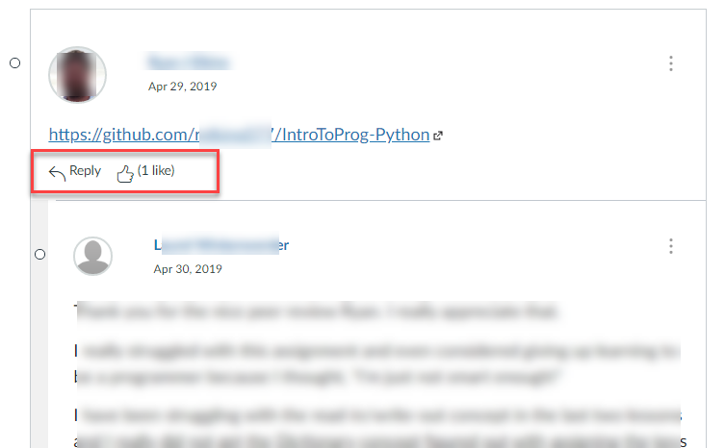

Figure 4. Doing a peer review

Congratulations! You are done!